City of Melbourne Open Data & Personal API key
Team uses City of Melbourne Open Data's API to complete data analysis. The data science team theoretically does not use any local files, ensuring analysis can be replicated. To improve access efficiency, we use API keys. We use personal API keys now.

Process
The following is the registration process:
First, enter City of Melbourne Open Data and click to register or log in.
https://data.melbourne.vic.gov.au/pages/home/
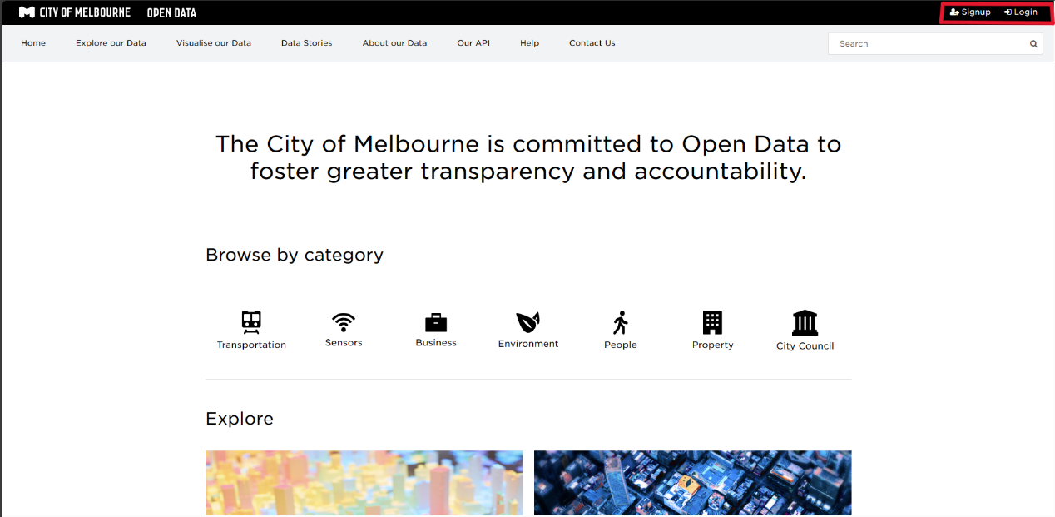
Complete registration
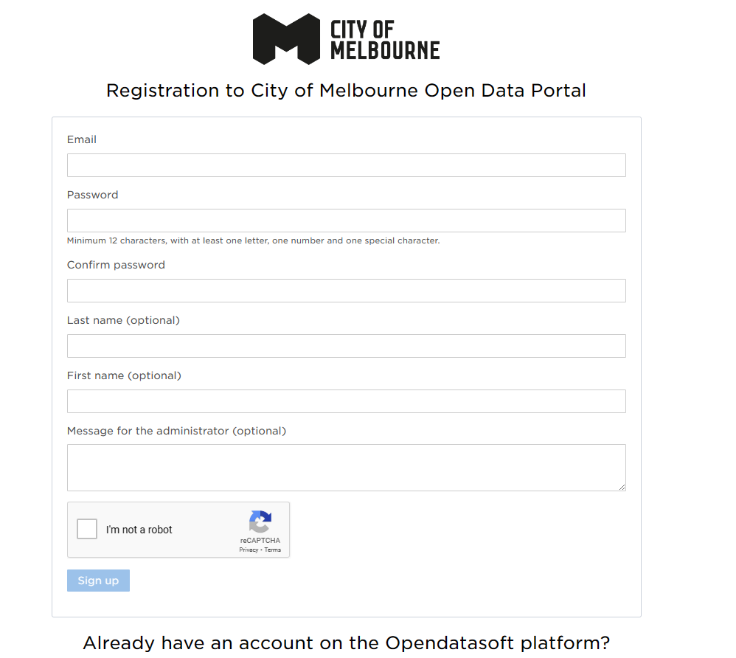

After logging in, click your name to enter your account and create a key. This key is your key. You should delete this key from this page after the unit is over.
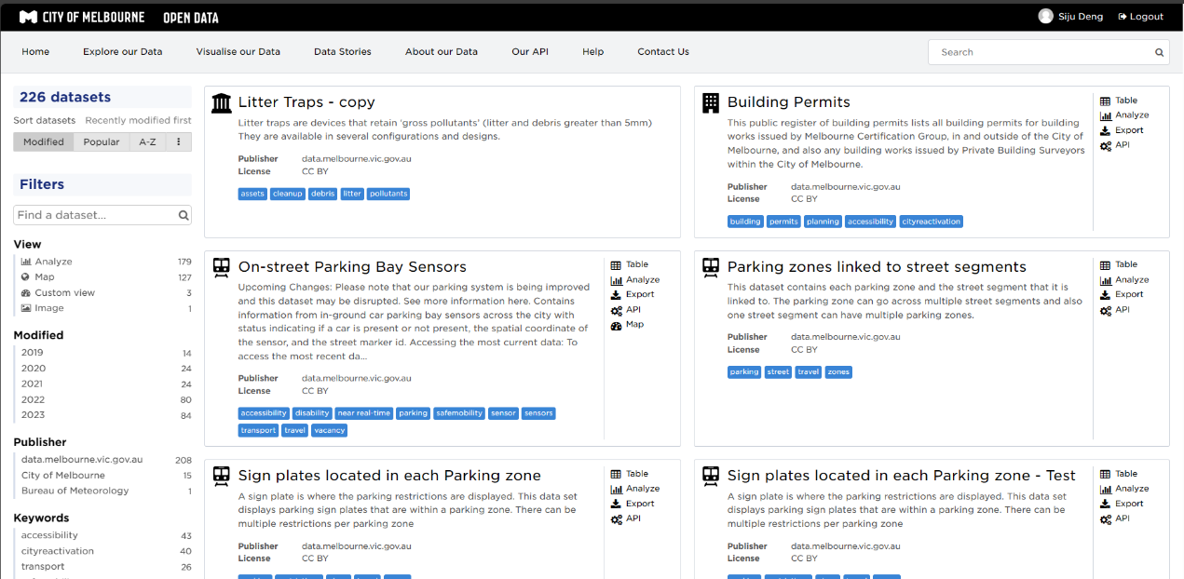

Make sure your Key is the new Key. And you deleted it after the semester. We don't want the Key to expire or leak. Please make sure your code can quickly change keys.

Author
Siju Deng

